**An example of strategies used to help students become better writers**

Students’ task was to write a story. After teaching the narrative structure and revising the sizzling starts, students had an opportunity to write. After checking their work, I realised that students did not develop their characters well, provided little and mostly direct descriptions with no developed character traits. They also haven’t developed the problem or the resolution to a satisfactory level. Many things happened suddenly, too many ideas in one paragraph and generally, resolutions consisted of one sentence.

I have replanned all of my English lessons for the next two weeks to include targeted teaching in order to help students learn, correct some bad habits in writing and give them opportunities to practice new skills.

Firstly, as per the seven Steps PD, I taught the students to brainstorm their ideas and chose their best one – not the first idea that comes to mind. We do this now almost daily to help practice and develop the brain muscle memory. I have adopted this in other subject areas as well as the improvement in student work is high.

Then, we spent a few lessons learning how to plan the story using both the ‘Story Graph’ and the ‘Story Mountain’ graphic organisers. At this point students had another opportunity to write a story using one best idea, planning and a sizzling start. ([image 1](SSStory%20Graph.PNG), [image 1a](SSStoryGraphUseExample.PNG))

To help the students with the problem development, I organised a Tightening Tension activity. I brought a bag with items in it that have an unusual feel to them when touched. Students were not allowed to look inside the bag, just put their hand in and feel items. Some were very excited about it some too scared to do it as the anticipation and excitement almost turned into fear. The whole class then brainstormed some ideas around whet they could hear, see, think, feel, smell etc. as they were lining up, talking to others and getting ready to put their hand in. We then wrote those out together as a pebble, rock, boulder problem development. Students then worked in pairs to develop the problems in the stories they wrote. They discussed first, then wrote dot points to plan and lastly, wrote. [(image 2)](problem%20development%20lesson.jpg)

After these lessons, I then focused on teaching character development using the ‘Act it Out’ activity. I have put up the ‘Show Don’t Tell’ posters on the board, students brainstormed some characters (heroes and villains) and then we wrote direct and indirect descriptions of the characters – whole class activity. Indirect descriptions were too difficult to do, which I anticipated. We then brainstormed what kind of a person would be a villain, what kind a hero. Students came to the front and acted like a hero (walk, talk, body language, tone of voice). Same for the villain. After this, they acted out emotions. While a group was acting angry, surprised, annoyed, happy etc, the rest had to describe those students by observing the body language, facial expression and the tone of voice. Students rotated so that everyone had an opportunity to act and to describe. Some examples written on the board. [(image 3)](guided%20writing1.jpg) [(image 4)](students%20acting_LI.jpg)

Students then worked in pairs to describe their characters. The following lesson, students were given an opportunity to write a whole story again or to continue from the previous one. When finished, they checked each other’s work and provided feedback on: what was missing, what could be improved and what was done well.

After this we worked on persuasive writing and came back to narrative writing in Term 3. Again, after reading the stories, problem and resolution development was lacking. We revisited the ‘Tightening Tension’ and there was some improvement but not enough for the stories to be well connected and coherent.

To help students, I organised the ‘Sherlock Holmes’ activity. The mystery story was started (The Dilemma – see below) and the students had to brainstorm the problem using discussion questions (see below). Working with a partner in a Think Pair Share activity, they thought about the best problem, developed it from pebble to boulder to rock and shared with their partner. Students then gave each other feedback.

Note: I paired the students strategically for this activity.

To help students develop a habit of using descriptive language and precise vocabulary, we do sentence builders. We start with a very simple sentence and rewrite three times. With each rewrite we use figurative language in a different way to develop that sentence into not only complex but creative complex sentence. It’s helping students understand how to use specific vocabulary to develop their ideas. ([image 5](build%20a%20sentence.jpg), [image 6](sentence%20builder-student%20work.jpg))

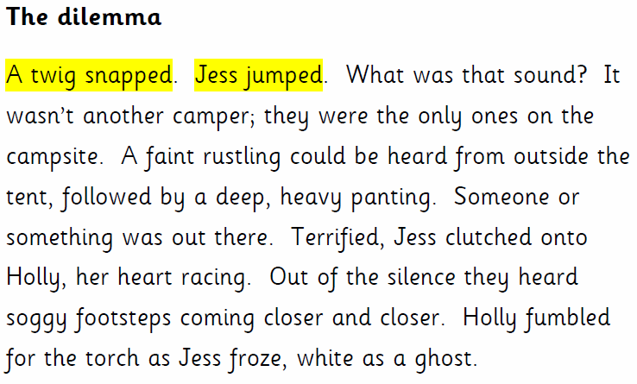



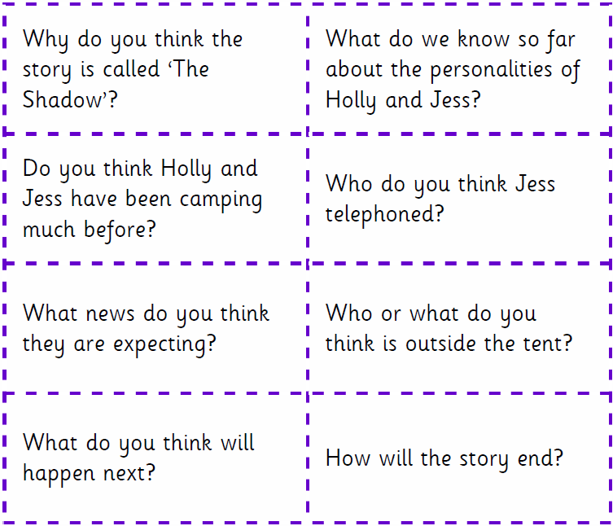

Discussion questions for learning problem development



